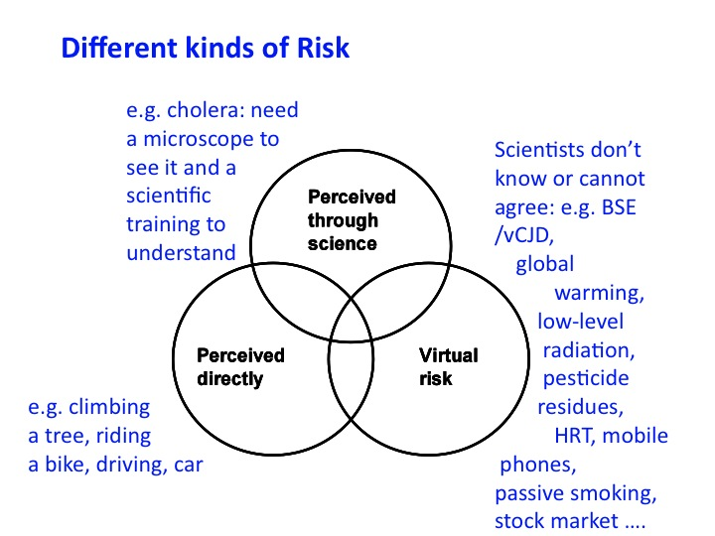

# Three Risk Framing Devices

For [Grant’s London Investment Conference,](http://www.grantspub.com/conferences/index.cfm) 24 February 2011

John.Adams@UCL.ac.uk

1. It is important to be clear about the type of risk you are dealing with. Directly perceptible risks are dealt with instinctively and intuitively. Virtual risks are culturally constructed – when the science is inconclusive people are liberated to argue from pre-established beliefs, convictions & prejudices. When virtual risks – sometimes called unconfirmed hypotheses – get mistaken for risks about which science has clear and useful advice to offer, much confusion results. This is the circle in which one finds problems characterised by complexity and uncertainty.

The risk thermostat

# Risk Management: where are the keys?

3. The less conclusive the science, the

more influential become the filters

through which risks and rewards are

perceived. This typology captures commonly encountered types.

* the **egalitarian** is fearful and risk averse – if you can’t prove it’s safe assume it’s dangerous & invoke the precautionary principle.
* the **individualist** is an optimist and pragmatist - if you can’t prove it’s dangerous assume it’s safe – tends to focus on the rewards of risk.
* the **fatalist** ducks if he sees something about to hit him – otherwise *que sera sera*.
* institutional risk managers are professional **hierarchists**. They commission more research to find the right answer. Very uncomfortable in the presence of virtual risk.



2. Risk management is a balancing act. Institutional risk management commonly ignores this fact. The job specification of most institutional risk managers obliges them to deal only with the bottom loop – judgements about safety ought not, they insist, to be “corrupted” by concerns about rewards. A one-sided concern for reducing accidents without considering the opportunity costs of so doing fosters excessive risk aversion - worthwhile activities with very small risks are inhibited or banned. Conversely, the pursuit of the rewards of risk to the neglect of social and environmental “externalities” can also produce undesirable outcomes.

Perceptual filters

# The drunk looks for his lost keys under the lamppost because that is where it is light

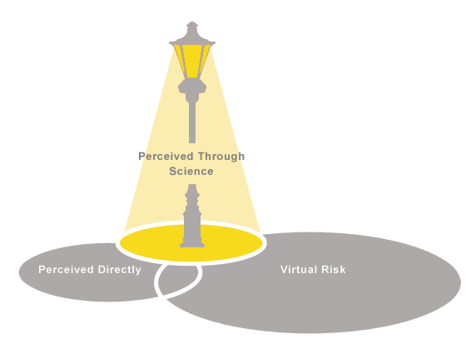

*Some seek to distinguish between “objective” or “actual” risk and “perceived” risk. But risk is a word that refers to a future that exists only in the imagination –* ***all*** *risk is perceived.*

**Directly perceived** risk (much operational risk) is managed using ***judgement*** – a combination of instinct, intuition and experience. We do not undertake a formal probabilistic risk assessment before crossing the road.

**Risk perceived through science.** This is the realm of quantified risk assessment – the scientist, the conductor of clinical trials, the epidemiologist, the actuary, the cost-benefit analyst. This is the circle that dominates the risk literature – often, *but not always* – successfully. However objective in appearance, assessments in this circle rest ultimately on subjective assumptions.

**Virtual risk*.*** If science cannot settle an argument, people feel liberated to argue from their pre-established convictions, beliefs, prejudices, superstitions. Here we encounter arguments about values, the nature of *nature,* standards of proof, the precautionary principal and the role of regulation. In this circle, as with directly perceptible risk, we are thrown back on ***judgement***.

**Some references**

[7/7: What Kills You Matters - Not Numbers](http://www.socialaffairsunit.org.uk/blog/archives/000512.php)**,** Times Higher, 29 July 2005 –

[Risk Management: Making God Laugh](http://john-adams.co.uk/wp-content/uploads/2006/making%20god%20laugh%20for%20financial%20world%20FINAL.pdf) – published in the inaugural issue of *Financial World −* February 2006 -

“[Risk Management: it’s not rocket science – it’s more complicated](http://www.socialaffairsunit.org.uk/blog/archives/000318.php)” awarded the Inaugural Roger Miller Essay Prize by AIRMIC (Association of Insurance and Risk Managers) -

My book ***Risk*** – available from [Amazon](http://www.amazon.com/Risk-John-Adams/dp/1857280687/ref=sr_1_1?ie=UTF8&s=books&qid=1202903740&sr=8-1) and my website – [www.john-adams.co.uk](http://www.john-adams.co.uk)